A Major Project on
Record of Student’s Profile and Fees Structure

A
Major Project Report
Submitted to

Rajiv Gandhi Proudyogiki Vishwavidyalaya, Bhopal (M.P)



Submitted by
Payal Panchal (0873CS101044)

In Partial fulfillment of the degree in
Bachelor of Computer Science and Engineering

2010 - 2011

Project Coordinator Project In-Charge
Prof. Sandeep Mathariya Prof. Rashid Shekh

DEPARTMENT OF COMPUTER SCIENCE AND ENGINEERING
SRI AUROBINDO INSTITUTE TECHNOLOGY, INDORE (M.P)
Table of content

- .Introduction
  - Objective
  - Purpose
  - Scope
  - Problem identification
  - Methodology
  - Software Requirements
  - Hardware Requirements
  - Execution Efficiency
- Data flow Diagram
- Input forms
- Output forms
- Language Selection.
- Testing
- Limitations
- Conclusion & Future enhancements

SRI AUROBINDO INSTITUTE TECHNOLOGY, INDORE (M.P)
Department of Computer Science and Engineering



CERTIFICATE

This is to certify that Miss. Payal Panchal B.E (Computer Science and Engineering) fourth year session 2016 – 2017 of this institute have completed the project work “Record of Student’s Profile and Fees Structure” based on syllabus prescribed by Rajiv Gandhi Proudyogiki Vishwavidyalaya, Bhopal.

Prof. Sandeep Mathariya Prof. Rashid Shekh
Project Coordinator Project In charge

Dr. D. K. Mishra Dr. Apurva Gaiwak
Professor and Head CSE Director, SAIT

ACKNOWLEDGEMENT
The completion of this project work could be possible with continued & dedicated efforts & guidance of large number of faculty & staff members of the Institute. I acknowledge our gratitude to all of them. The acknowledgement however will be incomplete without specific mention as follows:

We express our profound sense of gratitude to our project guide Mr. Sandeep Mathariya for their continuous encouragements & guidance during the project period.

We also express our sincere thanks to the HOD (CSE) Dr. D.K. Mishra for encouragement & providing all the facilities in the department.

We would like to extend our gratitude to the Director Dr. Apurva Gaiwak for their valuable encouragement & approval of the project work.

We are thankful to all staff members of the CSE department and my friends for their timely help co-operation and suggestion for my project work. Lastly but not the least, we must express thanks to our family, without their moral support it was impossible for us to complete this minor/major project work.

Submitted by:
Payal Panchal (0873CS101044)

Introduction

1.1 Objective

The objective behind making this project is to solve the problem of maintaining manual record of students in college and schools.
Student Management System deals with all kind of student details, academic related reports, college details, course details, curriculum, batch details and other resource related details too. It tracks all the details of a student from the day one to the end of his course which can be used for all reporting purpose, tracking of attendance, progress in the course, completed semester’s years, coming semester year curriculum details, exam details, project or any other assignment details, ﬁnal exam result etc. Our design can facilitate us to explore all the activities happening in the college, even we can get to know which faculty is assigned to which course, the current status of a student, attendance percentage of a student and upcoming requirements of a student. The student management system is an automated version of manual Student Management System. It can handle all details about a student. The details include college details, subject details, student personnel details, academic details, exam details etc. In case of manual system they need a lot of time, manpower etc. Here almost all work is computerized. So the accuracy is maintained. Maintaining backup is very easy. It can do with in a few minutes. Our system has two type of accessing modes, administrator and user. Student management system is managed by an administrator. It is the job of the administrator to insert update and monitor the whole process. When a user log in to the system. He/she would only view details of the student. He/she can’t perform any changes. Our system has seven modules, they are administrator, student, course, department, exam, attendance, and section. These modules and its attributes with entity relationship module presented in the ER diagram section.

  - Purpose:
This solution is basically made for solving the problem of maintaining manual record and collecting the large amount of student’s data in registers because these manual procedure is very hard to maintain and these records have chances to get wear and tear and sometimes to get lost also.
There are many software development companies that oﬀer student management system for schools in the market. There are records on the past years projects on student management system is done by students. Through the researches, it is observed that there are features where this project can adopt and implement. One of it will be with addition of new course or class, or even upgrading of students to the next level, the school administrator can easily.

to register all of them within a particular class into the new one using just a page and not having to register one at a time. With this feature, it helps administrator to save time as well as increase their eﬃciency.

  - Scope:

This product having a basic user interface and because of that this product don’t take time to understand its functionality and how to operate and due to this feature this product Is become a very high and optimal usability.

  - Problem Identification:
The major problem with the manual records are to get wear and tear and because of that sometimes these manual paper register records catches fire and these records are not quite portable when these record registers are in large amount.

  - Methodology :
In this project we are here using the agile approach to develop this product and because of that we are able to do reverse iteration on the development phase.

Systems Development Life Cycle (SDLC) is the most common process adopted to develop a project and not surprisingly, this project is following this model too. To be precise, waterfall model is being applied. Waterfall model is a sequential model process where the input of a phase actually results from the previous phase.

There are ﬁve phases in this model and the ﬁrst phase is the planning stage. The planning stage determines the objectives of the project and whether the project should be given the green light to proceed. This is where the proposal submission comes into picture. After obtaining the approval, the next phase is analysis. Gathering and analyzing the system and user requirements is essential for entry to the design step. With the user requirements gathering completed, there is a need to prepare the resources for the project. Be it software or hardware components, careful consideration and selection is to be taken care at this stage. The decision on the appropriate resources to be used is
further elaborated under the subsections below. The next step is to design the system and database structure. Results from the analysis and preparation that were concluded from the previous stage are put into action. With the user requirements in mind, the ﬂow of the system is planned and the user interface is designed to suit their easy navigation needs. In addition, the number of tables, attributes, primary and unique keys of the database is listed. After completing the design, actual coding begins. Database is created and codes are written.

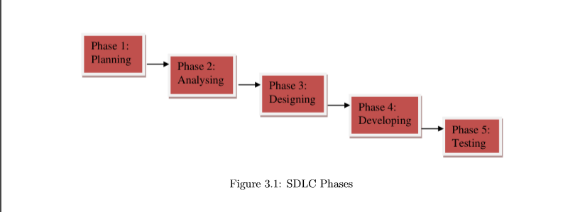

Some of the codes required amendments and improvement to it so these are being developed at this fourth stage of the waterfall model. With the development completed, testing will begin.
The codes and database are tested to ensure the results obtained are as intended. More time is spent on both development and testing stages because it is inevitable to have errors and issues and buﬀer time is allocated for troubleshooting.

  - Software Requirements:

- IDE: TurboC3 IDE/Compiler for development of this project.
- System Files for execution of the program.
- External Files and Libraries.
- User defined libraries.

IDE:
IDE here IDE stands for the Integrated Development Environment inside which our actual code is going to be program.

System Files:
These types of files contain the number of inbuilt and required files for the successful compilation and running of our code.
These files also help our project to convert into the executable file.

External Files and libraries:
In this type of files we count those libraries which are needed to add on the some extra features to our code and to make it more responsive.

User defined Libraries:
These files are made by user to give backend support and to modulate our lines of codes into the sub modules for maintaining the symmetry between the whole systems.

  - Hardware Requirements :
This project was working on the Application as a service methodology and because of that this project needs a desktop computer and no other special hardware.

This project having an executable file which is directly able to run on any windows and to generate the output.

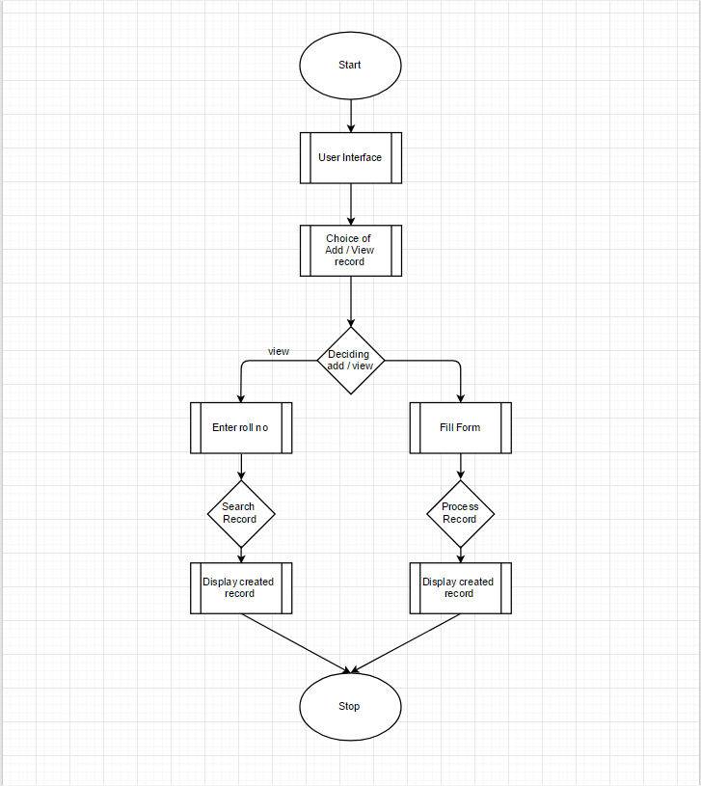
- Data Flow Diagram:

Data Flow Explanation:

Start:
This is the point where the whole process gets start here the user launch the application for performing the task.
User Interface:
Here at this point the user interface loads and gives choices of tasks to the user and then use selects an option among the given choices and proceed to the next phase.
Choice of add/view:
Here in this phase the system judges the input given by the user as his choice and then system validates is the given command is correct or not and proceed for the next process.
If the command is Add:
If the process is to add then system gives a form to the user to fill and validate the information and proceed to the next process.
Display created Record:
This is the position where the system display the created document and ask the question for validating and further correction and the final confirmation of the adding record.
If the command is “view”:
If the command is to view the record then the system ask to the user to input the roll no of the student and search the record.

Display the record: In this process the system search the particular record associated to the roll no and display to the user.

Stop: This is the termination state of the System after which the system gets terminate.

- Input Form:

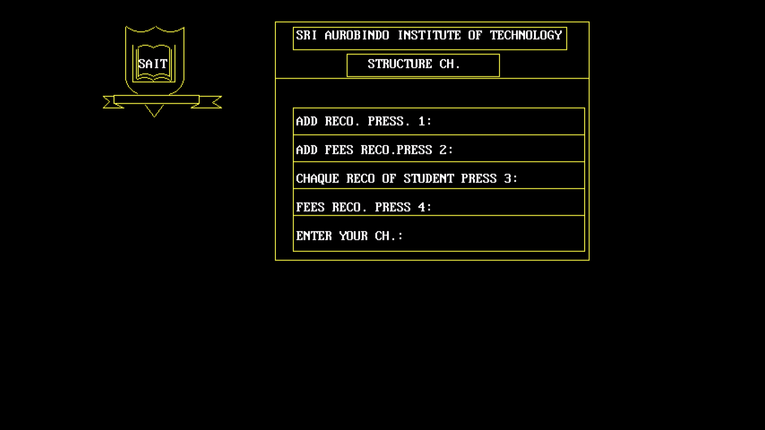

- This Input form is having a basic Graphic User Interface (GUI).
- Because of this GUI it becomes very easy to understand.
- It doesn’t need any extra efforts to get the hands on this project.
- This is an extra beneficial point that it doesn’t need efforts to operate it.

- Output Form:

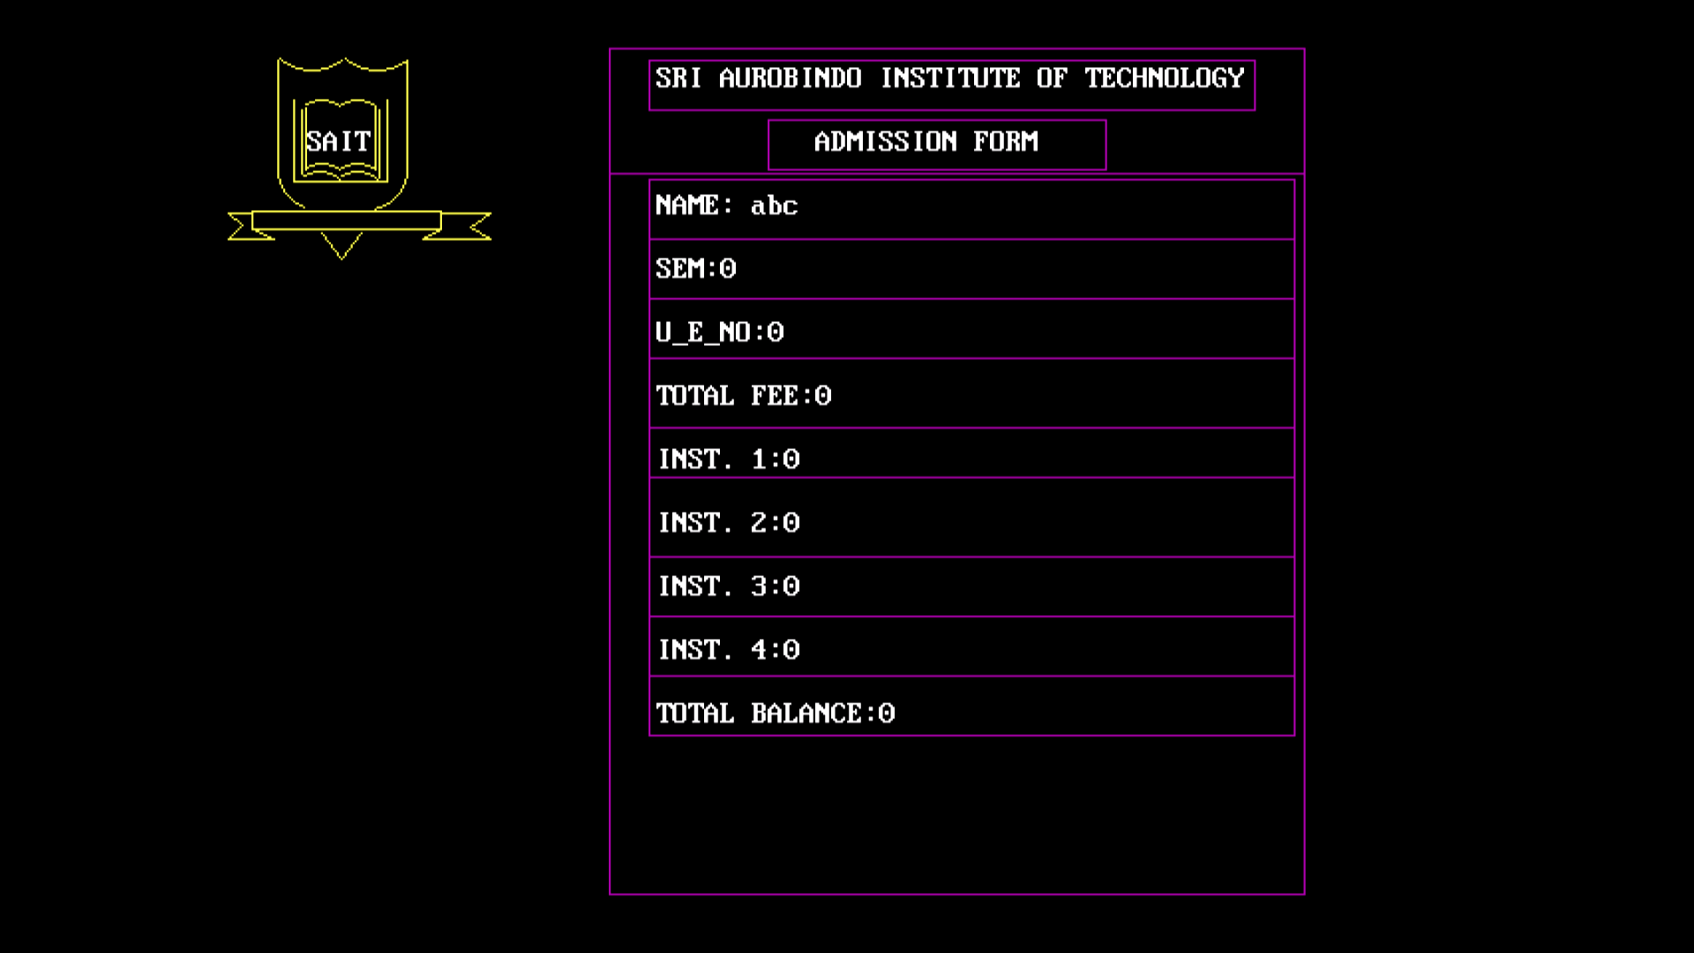

- The output window also contain a very basic GUI.
- Because of the basic GUI it is much easier to understand.
- Simply user ability.
- Optimal functionality.
- Fast Execution.

- Language Selection:

There are many languages available in the market. VBScript, Perl, JSP (Java Server Pages), ASP (Active Server Pages) and PHP (Hypertext Pre-processor) are some of those commonly used. Yet for this project, C is the language that is utilized for the coding piece because it is a Desktop based project. Being a widely-used open source language, it is free for everyone to use and is especially suited for fast execution based development. There are many advantages for using C thus no need for the switch to another language. Other than being a freeware, there are many free upgrade packages easily available. The other beneﬁt of choosing C is the ease in installation. On the other hand, other languages coded language; it is therefore more complex to understand and to do coding further exploring on the processing speed against other languages. Beyond and above, the compiling time and speed for C is faster and more eﬃcient.

- Testing:

We have tested our solution much time in real world scenarios and it performs well every time and because of that it becomes very useful.

- Limitations:

- Like every solution this solution is also having some limitations.
- This project is not platform independent and because of that it is only runs on the windows Operating system.
- This is the only limitation of this project and the only one drawback of this project.
- But I make sure that in future in the upgrade if this solution the next solution having better GUI better response than existing one and it is platform independent also.

- Conclusion and Future Enhancements:
Simplicity is never simple. As we have seen in this project, the process of creating a user friendly and straightforward platform that facilitates the administrator’s job is one ﬁlled with complexity. From understanding user requirements to system design and ﬁnally system prototype and ﬁnalization, every step requires in-depth understanding and commitment towards achieving the objectives of the project. Although the student database management module is not fully integrated to the system and used on real time, the system prototype demonstrates easy navigation and data are stored in a systematic way. Overall, eﬃciency has improved and work processes simpliﬁed. Although all the objectives have been met, the system still has room for improvement. The system is robust and ﬂexible enough for future upgrade using advanced technology and devices.

